



Computer Science  
1411363  
Software Engineering I

**Wild Fire Prediction System**

**Phase 1: Software Requirement Specification Document**

**Students name:**

Halima Khalifa (U16106701)

Reema Alharbi (U17100706)

Maryam Ali (U17101015)

Fady A M Abulebda (U17105389)

Omar Yaseen (U18101281)

1.0 Introduction

1.1 Goals and objectives 3

1.2 Statement of scope 4

1.3 Software context 7

1.4 Major constraints 7

2.0 Usage scenario

2.1 User profiles 8

2.2 Use-cases 9

2.2.1 Use-Case Diagram 9

2.2.2 Use-Case Descriptions 10

2.3 Special usage considerations 15

2.4 Activity Diagrams 16

3.0 Data Model and Description

3.1 Data objects 36

3.2 Relationships 38

4.0 Functional Model and Description

4.1 Class diagrams 39

4.2 Software Interface Description 40

4.2.1 External machine interfaces 40

4.2.2 External system interfaces 40

4.2.3 Human interface 40

5.0 Behavioral Model and Description

5.1 Description for software behavior 43

5.1.1 Events 43

5.1.2 States 45

5.2 Statechart Diagram 49

6.0 Restrictions, Limitations, and Constraints 53

7.0 Validation Criteria

7.1 Classes of tests & 7.2 Expected software response 54

7.3 Performance bounds 56

Phase 1: Software Requirement Specification Document

1.0 Introduction

An overview of the entire requirement document is given in this section. All software data, functional and behavioral specifications are defined in this document.

1.1 Goals and objectives

The main goal of the project is to successfully develop an effective software that helps to predict wildfires in Australia for the upcoming wildfire season , the software will receive and use the data received from Weather Operations Center Geospatial Analytics in order to study the information and the interactions between factors that cause the wildfires , it will be very efficient software since it will solve a major problem that causes a lot of loses .

The objective of the software development make it necessary that the project requirements are understood correctly and it’s designed in a way that suits the need of the end-user, Various UML diagrams and different scenarios have been included in this document to provide a clear picture of the software.

The main purpose of the software is to predict the wildfires in Australia for the upcoming seasons, it will maintains all information needed to have a good prediction, locations , temperature , humidity and wind , The system will maintain relevant information and have functions for each component .

The weather center will record all operations and generates reports about the general situation and the fire predictions .

1.2 Statement of scope

The scope of this project is to provide a database to the data scientists and the authority which includes, the weather center, government and firefighters that stores the information related to the wildfires affected areas in Australia during the month of February 2021 which will help preventing losses that are caused by the wildfires as much as possible. Easy format will be provided to be easily used by the citizens and managed easily by the data scientists and the authority with no issues. The application will be available to install for all the people who live in Australia.

If an authority or a data scientist access the application, they will be required to login with their unique ID and password that will be given to them whereases the citizens are required to sign up before being able to use the application. We will have three access levels, the highest level which is level 1 is for the authority, level 2 is for the data scientists and level 3 which is the lowest is for the citizens.

The authority can login and view their account information such as full name, email address and job. Also, they can send warning alerts to the citizens who are in the affected areas and view the dataset. In addition, they can view, modify, and print the overall wildfires report which predicts the expected areas affected by the wildfires and their corresponding dates and can search location to get the wildfires status of that specific location. Moreover, they can view the overall wildfires chart which shows statistics of the expected areas and dates of the wildfires. In the other hand, they have few limitations like not being able to add, update, and delete the data of the dataset.

The data scientists can do most of the things that the authority can do which are login, view their account information, view, modify, and print the overall wildfires report which predicts the expected areas affected and their corresponding dates. In addition, they can search for a certain location to get the wildfires status of that specific location and view the overall wildfire chart which shows statistics of the expected areas and dates of the wildfires. Moreover, they can do things that the authority cannot do which are view, add, and delete data of the dataset. Also, they can update the dataset by importing datasets. However, they have limitations like not sending or receiving the wildfires warning alerts.

The citizens login then a menu will appear where they can choose to view or print the report which include detailed information about the expected areas affected and their corresponding dates, search for a certain location to get the wildfire status of that specific location and view the chart that shows statistic of dates and areas covered by the wildfires. In addition, they receive warning alerts if the wildfire is expected to affect the area, they are in. Also, they can view their account information. Apart from that, they do not have the access to add, update, or delete data of the dataset, send warning alerts, and modify the fire prediction report.

The citizens will be asked about some of their personal information when signing up such as, name, contact number, address and email which will be then added to the system automatically after completing the signing up process. When a new employee is hired whether, it is a data scientist or an authority, he/she will be given a unique ID and password to access the application to be able to get access to the system.

The following table ranks the major processing functions:

|  |  |
| --- | --- |
| Essential | * Creating accounts for data scientists, authority which includes, the weather center, government and firefighters and citizens to use the application. * Add/update/delete information into the software about the detailed information of the expected areas affected by the wildfire and their corresponding dates in the overall wildfire report and chart by the data scientists and the authority. * Sending warning alerts to the citizens who are in the affected areas because of the wildfire by the authority. * Add/update/delete data of the dataset by data scientist. * Viewing information of the dataset by the authority. |
| Desirable | * Viewing account information by all users. * Ability to search for a specific location to get the wildfires status of that location by all users. * Print the overall wildfires report which includes dates and predicted affected areas. |
| Future | * Users from all over the world can access the software. * Police departments get high level access to the software. |

Major output of the project is detailed wildfire prediction report, detailed wildfire prediction chart, specific location wildfire status, sending warning alerts to the people who are in the affected areas.

1.3 Software context

Australian wildfires declared among the worst wildfire disasters in modern history. It has become important for software engineers to come up with a software that can predict wildfires before they happen. Use of this software will make it easier to keep track of all the wildfires that are happening, and upload prediction data will be easier. No wastage of time will be there since the software will be user-friendly. All users will benefit from this app. Citizens can view wildfire status and receive alerts from the authority. The authority can organize wildfire status data and send warning alerts to citizens. The data scientist can build models and import dataset.

Assessing the models and testing them. We need to create an app using many programming languages such as Swift, JavaScript, C++, and Python to deploy the framework in order to provide a user-friendly app that serves the function of the system.

1.4 Major constraints

In the development of the program, the key constraints are that the system should respond within the necessary limit defined in the project. The software is being developed, taking into account how the different users need to communicate with the system. It should be easy, user-friendly and should offer the best possible performance. The system on which the program will be mounted should be sufficiently advanced to perform all the necessary actions in a reasonable period of time.

2.0 Usage scenario

This section provides a usage scenario for the software. It organizes information collected during requirements elicitation into use-cases.

2.1 User profiles

Authority: The authority can the weather canter, government or firefighter which has the most access to the information in the database and can make changes to most of the data in it. They can view, add, update, and delete any information in the overall wildfires prediction report and chart. Moreover, they have the option to print the overall wildfires prediction report. In addition, they can search for a specific location to view its wildfires status. They also send warning alerts to the citizens who are in the affected areas and view the data in the dataset. They cannot modify the data that are in the dataset.

Data Scientist: The data scientists can view all information of the Wildfire Prediction System. They can view and modify the overall wildfire prediction report and chart, as well as printing the overall wildfire prediction report. They can view the wildfire status of a specific location. They have access to view, add, modify, and delete the data of the dataset. Apart from that, they cannot send or receive wildfires warning alerts.

Citizen: The citizen of access his/her own account, after signing up and get their unique ID and password. He/she can view and print the overall wildfire prediction report, view the overall wildfire prediction, view wildfires status in a specific location and receive wildfires warning alerts. He/she cannot make changes to the data in the database and cannot and cannot modify the overall wildfires report and chart.

2.2 Use-case

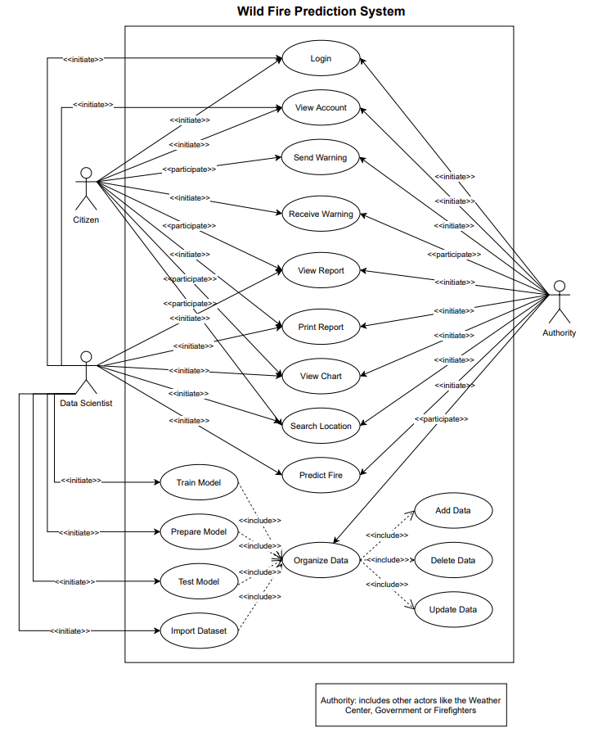2.2.1 Use-Case Diagram

2.2.2 Use-Case Descriptions

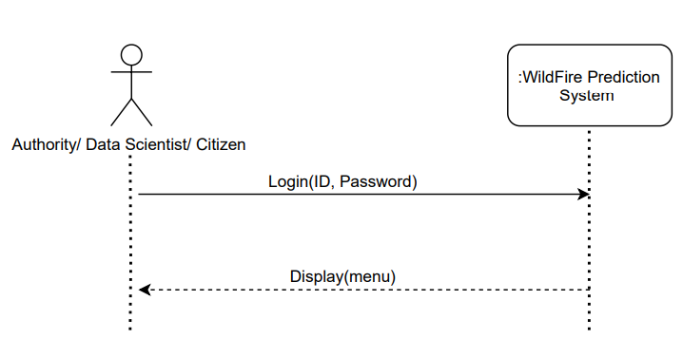**1) Log In**

* The authority, data scientist or citizen using the Wildfire Prediction App can log-in to the system.

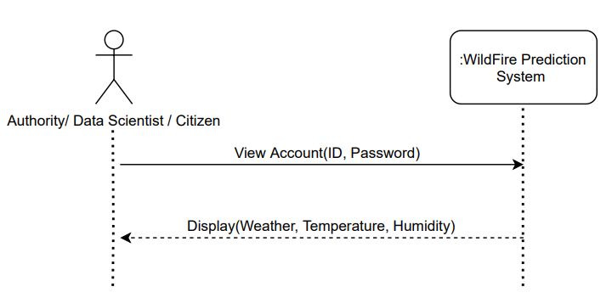**2 View Account**

* The authority, data scientist or citizen can view their account from the App

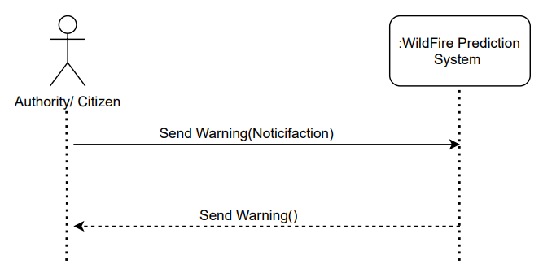**3) send warning**

* The authority can send warning alerts to citizens.

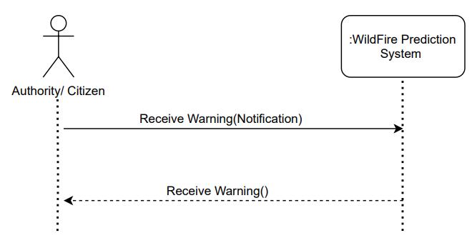**4) Receive warning**

* The citizen can receive warning alerts from the authority.

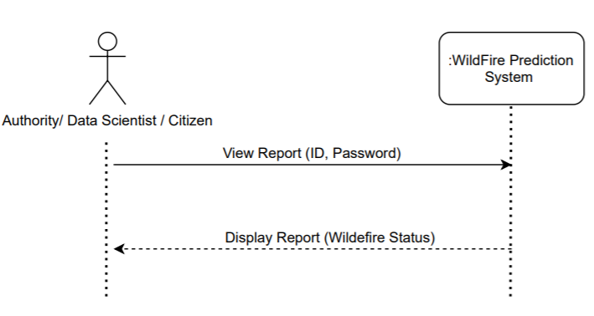**5) View Report**

* The authority, data scientist or citizen can view report that display wildfire status.

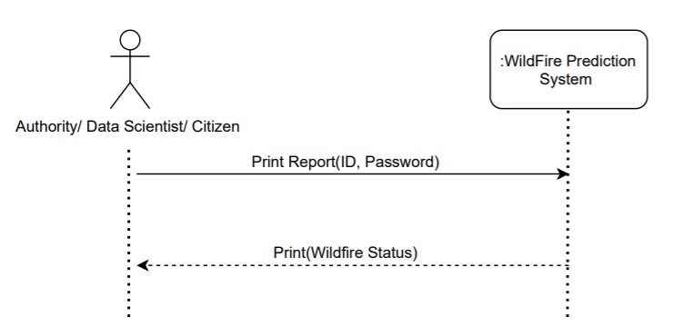**6) Print Report**

* The authority, data scientist or citizen can print report that display wildfire status.

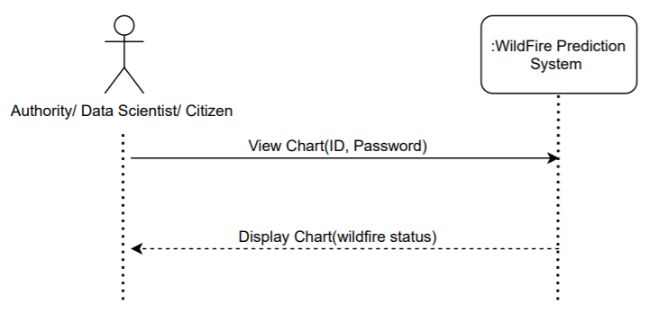**7) View Chart**

* The authority, data scientist or citizen can view statistical charts that display wildfire status.

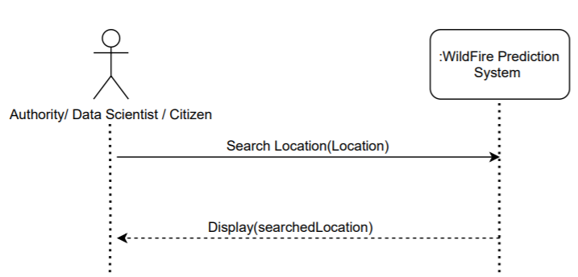**8) Search Location**

* The authority, data scientist or citizen can search locations that are affected by wildfire.

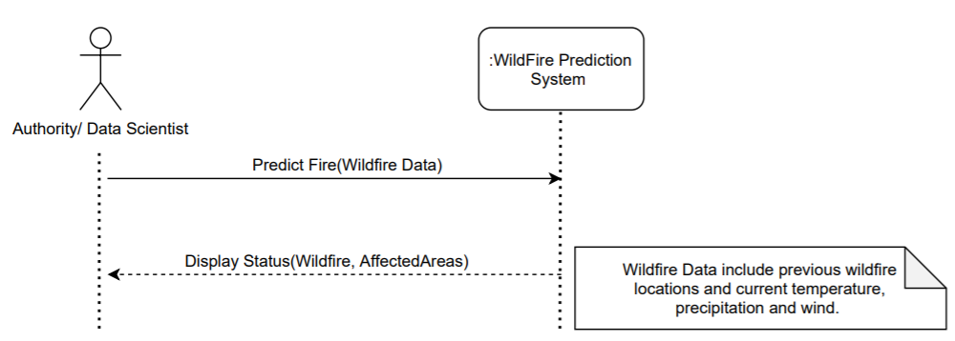**9) Fire Prediction**

* The authority or the data scientist can provide the system with wildfire data which is previous wildfire locations, current temperature, precipitation and wind to predict wildfire status.

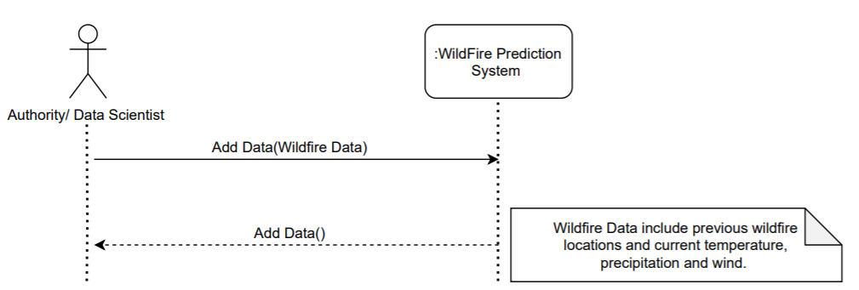**10) Add data**

* The authority or the data scientist can add any wildfire data required in the system.

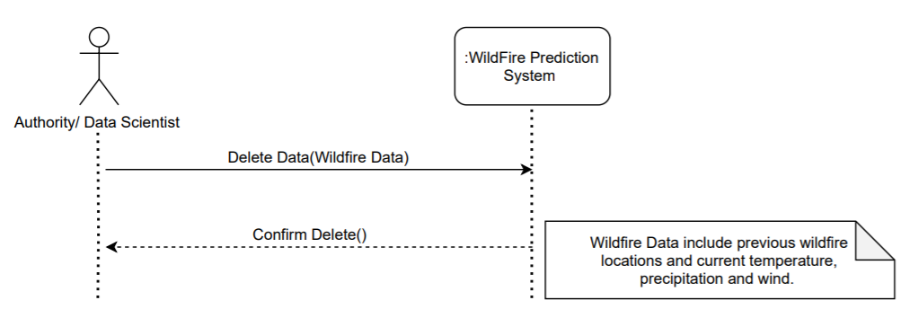**11) Delete data**

* The authority or the data scientist can delete any information not required in the system, example: deleting information about old data.

**12)Update data**

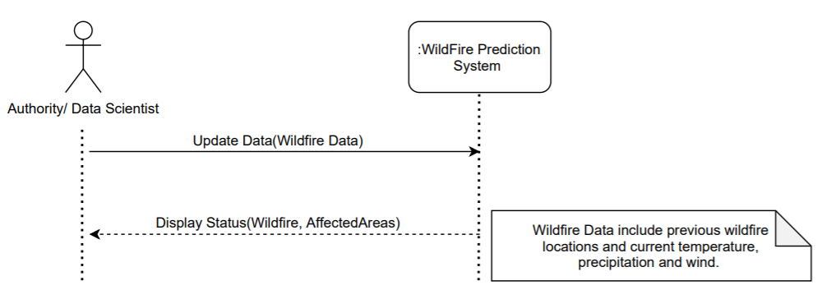

* The authority or the data scientist can Update any wildfire data required in the system**.**

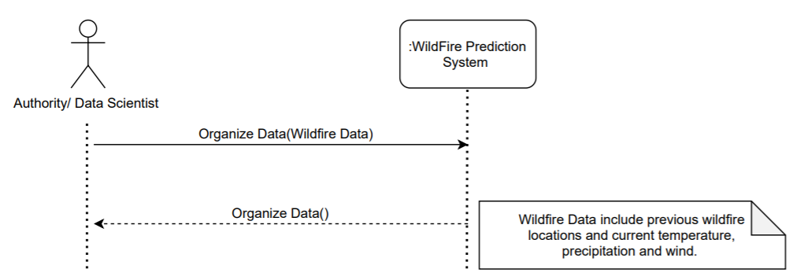**13) Organize Data**

* The authority or the data scientist can add any wildfire data.

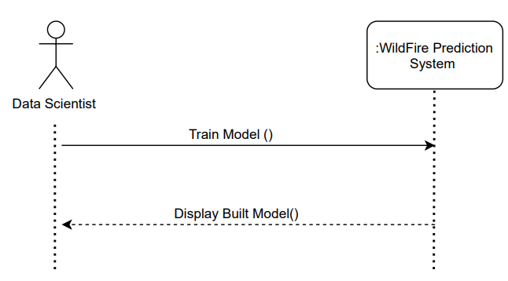**14) train model**

* The data scientist can train model.

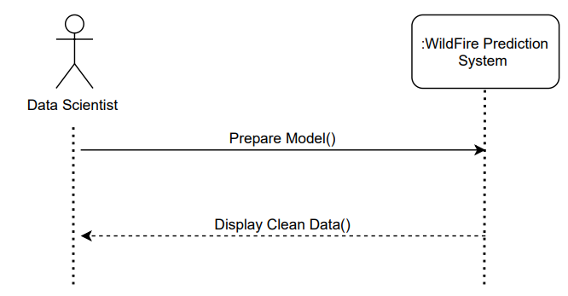15) Prepare Model

* The data scientist can prepare model by cleaning and transforming raw data prior to processing and analysis.

**16) Test Model**

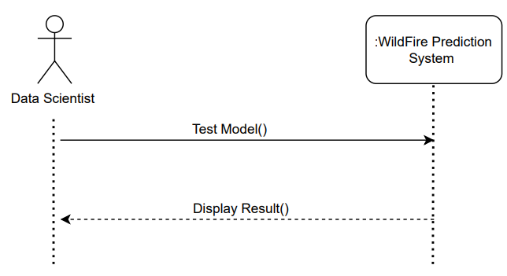

* The data scientist can test model to make sure it is working.

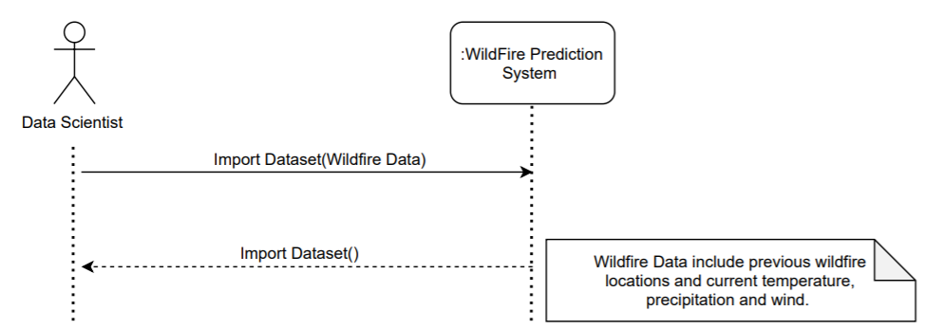17) Import Dataset

* The data scientist can import the wildfire data on the app.

2.3 Special usage considerations

All users need an ID to create an account in the system.

The user should enable location services and Bluetooth settings on their phones in order to view all weather information regarding their current location.

2.4 Activity Diagrams

data scientist/weather center

system

log in

verify ID and

password

is correct?

[

no

]

[

yes

]

choose delete

check access level and

display meneu

ask or

ID/password

Display error

choose type of

delete info

Ask for type of

delete info

Ask for delete

info

confirm the info

save and delete

confirm

[

yes

]

log off

[

no

]

The authorities are the only user that will be able to delete information or any data in the system. He will log-in to the system. The system will verify the ID and password. It will send an error message for incorrect ID and password and prompt for login again, indefinitely. Once the ID and password is verified, the system will check the access level of the user and display the menu accordingly. The function ‘delete information’ will be chosen by the authorities. The system will ask for the information that has to be deleted and the authorities will provide it. The system will ask for confirmation of deletion and, once confirmed, the information will be deleted. After that, the authorities will log-off.

data scientist/weather center

system

log in

verify ID and

password

is correct?

[

no

]

[

yes

]

choose update

check access level and

display menu

ask or

ID/password

Display error

choose type of

update info

Ask for type of

update info

Ask for update

info

confirm the info

save and update

confirm

[

yes

]

log off

[

no

]

The authorities will log-in to the system to update any type of information. The system will verify the ID and password. It will send an error message for incorrect ID and password and prompt for login again, indefinitely. Once the ID and password is verified, the system will check the access level of the user and display the menu accordingly. The function ‘update information’ will be chosen by the authorities. The system will ask for the type of information that has to be updated. The authorities will choose the type and then enter that information. The system, after receiving the information, will ask for confirmation. If not confirmed, the system will ask for the update information again. Once the authorities has confirmed the updated information, the system will save the update. The authorities will then log-off.

data scientist/weather center/ citizen

system

log in

verify ID and

password

is correct?

]

no

[

yes

choose view

report

check access level and

display meneu

ask or

ID/password

Display error

specify the report

ask which report to view

log off

Display the report

view the report

The ‘display report’ function can be chosen by the authorities, citizen and data scientist. The user will log-in to the system. The system will verify the ID and password. It will send an error message for incorrect ID and password and prompt for login again, indefinitely. Once the ID and password is verified, the system will check the access level of the user and display the menu accordingly.

Once the function ‘display report’ is chosen by the user, the system will ask for the type of report to be viewed and the user will provide this information. Once the report is displayed on the computer, the user can view it. If he wants a copy, the user can choose print and the system will print it and the user can log-off. If the user does not want a copy, he can simply log-off.

data scientist/weather center

system

log in

verify ID and

password

is correct?

[

no

]

[

yes

]

choose view

account

check access level and

display meneu

ask or

ID/password

Display error

Enters the ID of account to be viewed

ask for ID of the account to be viewed

log off

is correct ID?

no

[

]

]

yes

[

error message:wrong ID

display account

is Allowed to

view it?

error message:Access denied

[

no

]

[

yes

]

view account

The ‘view account’ function works the same for both the authorities and the data scientist. The / data scientist will log-in to the system. The system will verify the ID and password. It will send an error message for incorrect ID and password and prompt for login again, indefinitely. Once the ID and password is verified, the system will check the access level of the user and display the menu accordingly. The function ‘view account’ will be chosen by the / data scientist. The system will ask for the ID of the account to be viewed. The / data scientist will provide this information. If the ID is incorrect, the system will show an error message and ask for the ID again. Else, the system will check whether the user can view that account or not. That is, they can view the account of any citizen.

data scientist/weather center

system

log in

verify ID and

password

is correct?

[

no

]

[

yes

]

choose add info

check access level and

display meneu

ask or

ID/password

Display error

choose type of

add info

Ask for type of

add info

Ask for ADD info

confirm the info

save and add

confirm

[

yes

]

log off

[

no

]

The authorities will log-in to the system to add any type of information. The system will verify the ID and password. It will send an error message for incorrect ID and password and prompt for login again, indefinitely. Once the ID and password is verified, the system will check the access level of the user and display the menu accordingly. The function ‘add information’ will be chosen by the authorities. The system will ask for the type of information that has to be added. They will choose the type and then enter that information. The system, after receiving the information, will ask for confirmation. If not confirmed, the system will ask for the added information again. Once the authorities have confirmed the added information, the system will save the added info. They will then log-off.

authorities

system

log in

verify ID and

password

is correct?

[

no

]

[

yes

]

access database

check access level and

display meneu

ask or

ID/password

Display error

check the main for factors

display red light

display danger percentage

danger detected

]

no

[

display green light

keep track

above 75%

[

no

]

receive alert

[

yes

]

citizen

[

yes

]

The authorities will log-in to the system to add any type of information. The system will verify the ID and password. It will send an error message for incorrect ID and password and prompt for login again, indefinitely. Once the ID and password is verified, the system will check the access level of the user and display the menu accordingly. If the system detect danger it will notify the authorities if the danger is above 75% the authorities will send an alert to the citizens but id the danger is less than 75% the authorities will keep track.

3.0 Data Model and Description

This section describes the information domain for the software.

3.1 Data objects

Class name: Citizen

Major attributes:

* FName – First name
* MName – Middle name
* PhoneNumber

Class name: Account

Major attributes:

* Username
* Password

Class name: Data scientist

Major attributes:

* Fname – First name
* Lname – Last name
* Salary
* AccessLevel

Class name: weather authority

Major attributes:

* BranchLocation

Class name: Report

Major attributes:

* ReportWriter
* ReportDate

Class name: data

Major attributes:

* Location
* Temperature
* humidity
* predictions

Class name: government

Major attributes

* authority name
* location

Class name: fireprediction

Major attributes:

Firelocation

ThreatenedLocationpossibility

Class name: organize data

Major attributes:

Data complexity

3.2 Relationships

* Data scientist is a Citizen (inheritance)
* Weather authority is a government (inheritance)
* Weather authority has fire prediction system (Composition)
* Organize data is a data (inheritance)
* Weather authority has reports (Aggregation)
* Weather authority has Alert (Aggregation)

4.0 Functional Model and Description

This section describes the static structure of the software.

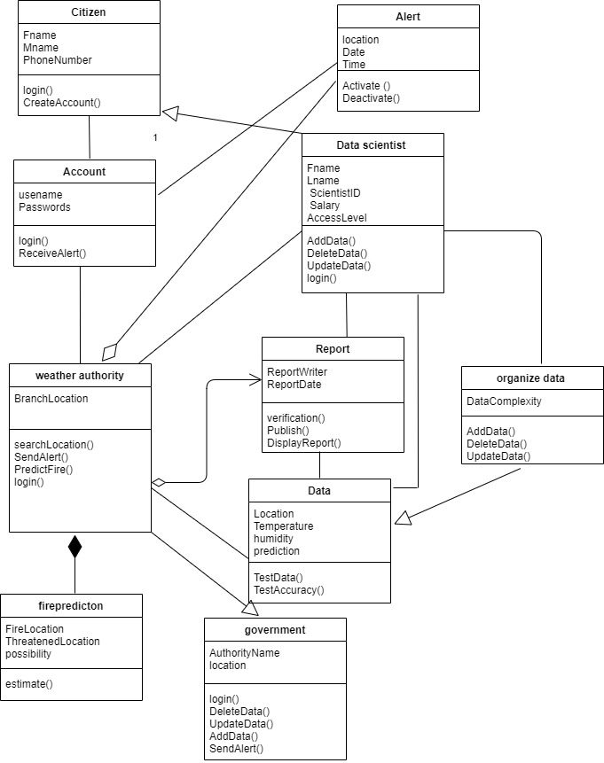4.1 Class diagrams

1

4.2 Software Interface Description

The software interfaces to the outside world are described.

4.2.1 External machine interfaces

* Printer to print reports.

4.2.2 External system interfaces

LAN (Local Access Network) – The software in the computer will be connected to the printer to log in and perform tasks.

4.2.3 Human interface

**Splash page:**

* This is the splash page of the app it contains the logo and the name of the app. The user is required to login if they already have an account or sign up if they are using the app for the first time.

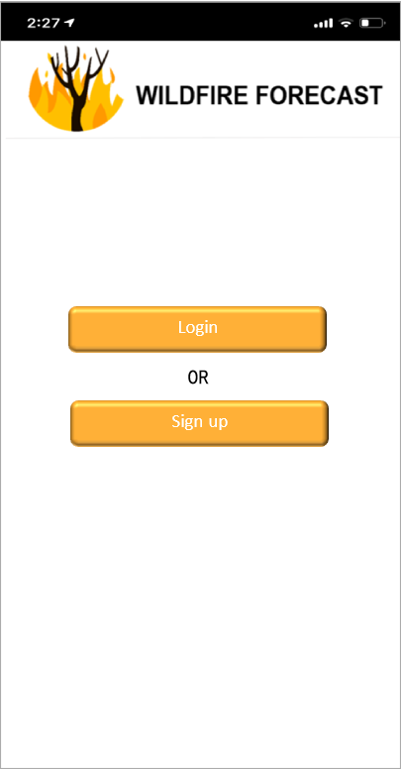

**Sign Up page:**

This is the sign-up page. First, the user has to select the account type:

* Citizen: represents people who want to receive alerts and reports about wildfire news.
* Data Scientist: represent a professional who wants to use the app gather data, prepare data, train a model, and test the model and finally import the dataset.
* Authority: represents people with authority who can send alerts, add data and delete data authority is divided into three sections:
* Government
* Weather Center
* Firefighter

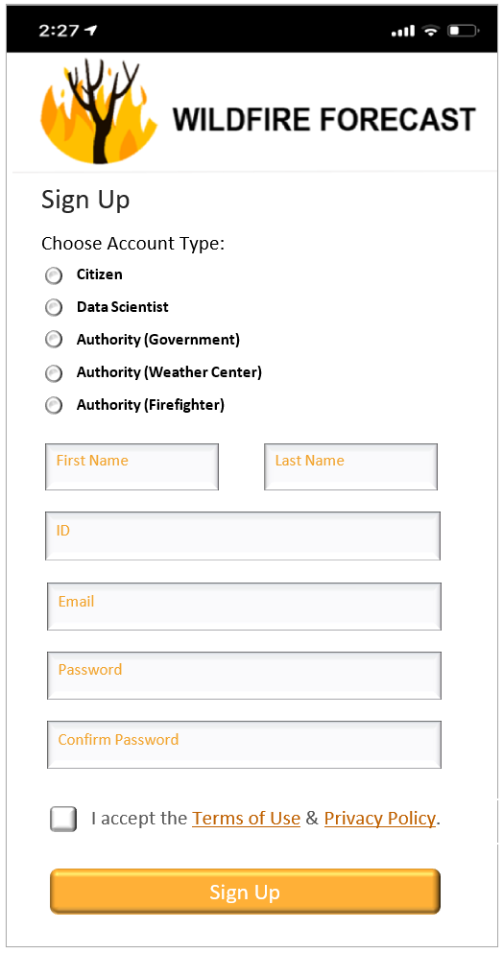

**Login page:**

* This is the login page. The user – whether they are a citizen, data scientist or the authority – are required to enter their ID and password to login.

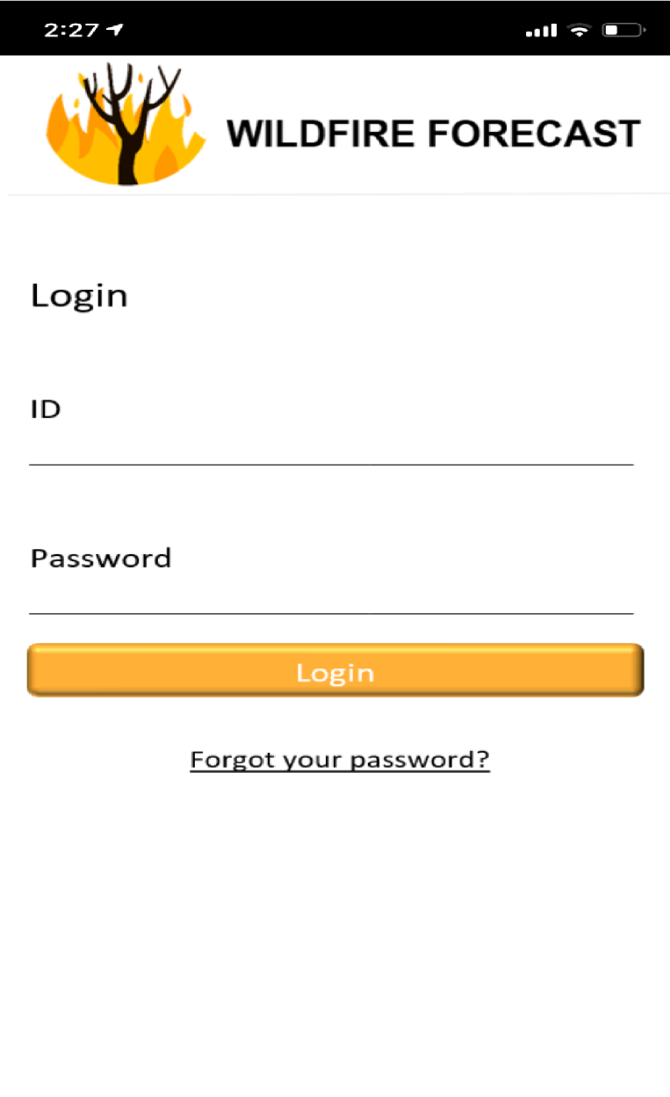

**Authority home page:**

* This page represents the home of Authority page. Authority can be the government, the weather center or a firefighter. The authority can send alerts, view report, view charts, search locations that are affected, predict fire and organize data.

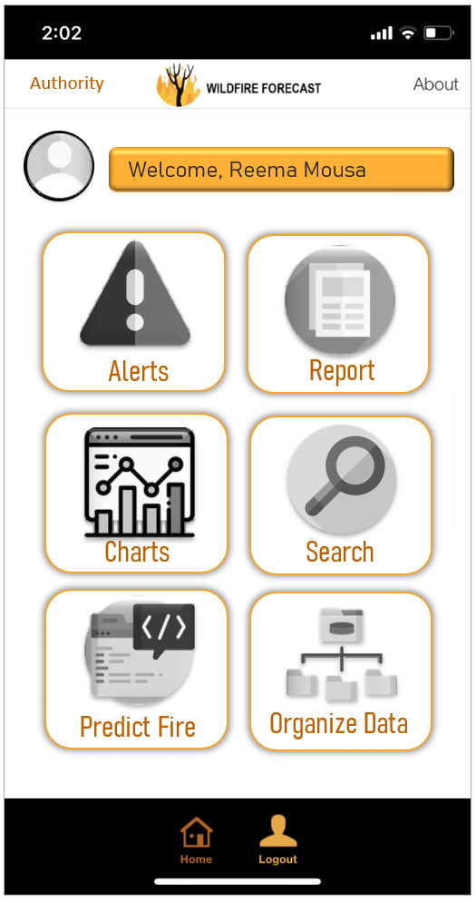

**Data Scientist home page:**

* This page represents the home of data scientist page. The data scientist can view report, view charts, search locations that are affected, predict fire, train model, prepare model, test model and import dataset.

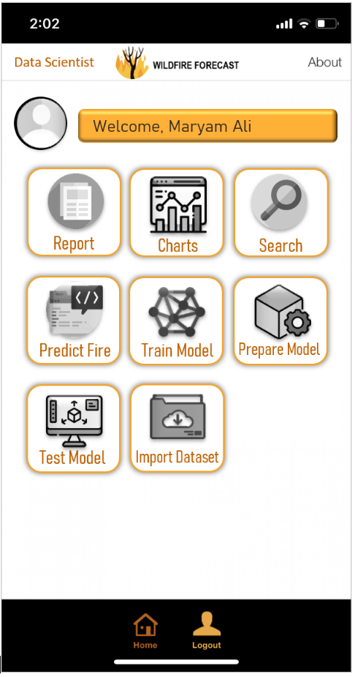

**Citizen home page:**

* This page represents the home of citizen page. The citizen can receive alerts, view report, view charts and search locations that are affected.

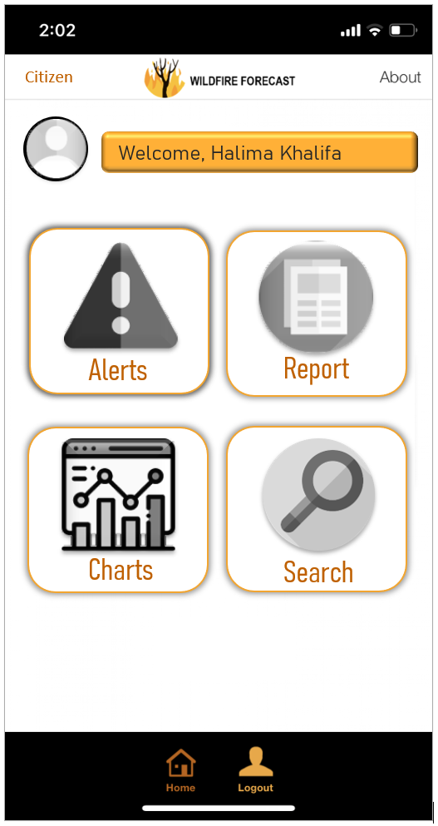

5.0 Behavioral Model and Description

A description of the behavior of the software is presented.

5.1 Description for software behavior

5.1.1 Events

**Events for Data Scientist**

* Data Scientist registers to the system
* Data Scientist view account
* Data Scientist log-in into their account
* Data Scientist view reports
* Data Scientist view charts
* Data Scientist predicts fires
* Data Scientist train model
* Data Scientist prepare model
* Data Scientist test model
* Data Scientist import dataset
* Data Scientist organize data
* Data Scientist prints reports
* Data Scientist log-out from their account

**Events for Authority**

* Authority registers to the system
* Authority view account
* Authority log-in into their account
* Authority view reports
* Authority view charts
* Authority predicts fires
* Authority organize data
* Authority prints reports
* Authority log-out from their account

**Events for Citizen**

* Citizen logs-in to the system
* Citizen logs-off the system
* Citizen views account information
* Citizen views report
* Citizen prints report
* Citizen views chart
* Citizen search location
* Citizen updates password
* Citizen receives warning alerts

**Events for Login**

* New account created
* Verifying access level of the account
* Existing account deactivated
* Password changed

**Events for Data**

* data can be added
* data can be updated
* data can be removed
* data can be organized

**Events for WildFire Prediction System**

* Log-in to the system
* Performing tasks
* Logging off of the system

**Events for Reports**

* Reports displayed
* Reports printed

**Events for Warnings**

* Warning alerts received
* Warning alerts sent

5.1.2 States

A description of the behavior of the system is presented.

|  |  |
| --- | --- |
| **State for ‘data scientist ‘** | **Description** |
| Login | Data Scientist can enter login information to enter, if it was correct they will procced if not they will be denied. |
| View account | The Data scientist can view their account information |
| Perform task | The Data scientist can access tasks according to their access level: Organize Data, View reports/charts, Test model. |
| Active | The Data scientist has an account and log-in . |

|  |  |
| --- | --- |
| **State for ‘Authority‘** | **Description** |
| Login | Authority can enter login information to enter, if it was correct they will procced if not they will be denied. |
| View account | The Authority can view their account information |
| Perform task | The Authority can perform tasks according to their access level: Send warning alerts, View reports/charts, Organize data. |
| Active | The Authority has an account and log-in |

|  |  |
| --- | --- |
| **States for ‘Citizen’** | **Description** |
| Active | The Citizen has an account and logs-in |
| View account | The Citizen can view their account information |
| Perform task | The Citizen can perform tasks according to their access level: View reports/charts, print reports |
| Updating password | The Citizen can update their password |
| Receives warning alerts | The Citizen can receive warning alerts once they have an account |

|  |  |
| --- | --- |
| **States for ‘WildFire Prediction System’** | **Description** |
| Login | User will enter the login information |
| Verifying access level | Check the user level to show specific tasks |
| Access level menu | The user is verified and can access tasks according to their access level |
| Access denied | An error message will be shown due to incorrect login information |
| Perform task | The user chooses which task to do |
| Task done | After the task is completed, the user can go back to homepage or log off |

|  |  |
| --- | --- |
| **States for ‘Login’** | **Description** |
| Account activated | When a new account is created |
| Verifying account | When the user logs in |
| password updated | When the password is changed |
| Account deactivated | When the account is removed |

|  |  |
| --- | --- |
| **States for ‘Reports’** | **Description** |
| Display | The Citizen, Data Scientist, and Authority request to display the report |
| Print | When the Citizen, Data Scientist, and Authority request to print the report |

|  |  |
| --- | --- |
| **States for ‘Warning Alerts’** | **Description** |
| Warning Alerts Received | The citizens will receive warning alerts |
| Warning Alerts Sent | The authority will send warning alerts |

5.2 Statechart Diagram

* 1. Data Scientist

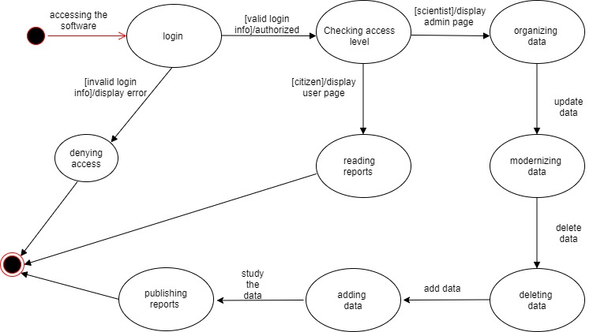

The data scientist will login to the software to organize data and writing repotrs and making predictions .

* 1. Warning Alert

When the Data Scientist & Authority detects any kind of Wild fires the Authority will send out a notification alert to all the citizens registered in the system.

* 1. WildFire Prediction System

The user will log-in the system. The first state will be verifying access, If the user is not allowed access, then they will be denied, and an error message will be displayed. If accepted, the page showing the tasks according to the user’s access level will be shown. The user will perform the task and once the task is done, they can either log off or return to homepage.

* 1. 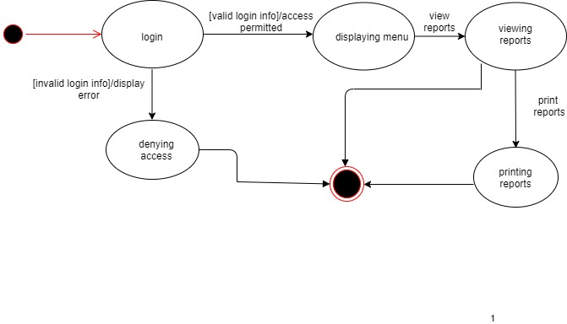Citizen

The citizen will login to the system after checking the login info and choose an action whether reading the reports or print them .

6.0 Restrictions, Limitations, and Constraints

Special issues which impact the specification, design, or implementation of the software are noted here.

Different issues can impact the specification, design, or implementation of the software such as:

1. Local hardware and software space (a server is needed to create the database (DB)).
2. The data provided .
3. Personal change.
4. Lack of team expertise.
5. The user access level.
6. Lack of top management support.
7. Time management
8. Inappropriate user interface.
9. Limited budget .

7.0 Validation Criteria

The approach to software validation is described.

7.1 Classes of tests & 7.2 Expected software response

|  |  |  |
| --- | --- | --- |
| **User** | **Scenario** | **Result** |
| Authority and Data Scientist | Do a DML statement (add, update, delete) for every data entry | Transaction is successfully committed (You can view the record) |
| Citizen | Do a DML statement | Error message (no privilege) |
| All users | View information for every data entry | Data is successfully appearing on screen |
| Authority and Data Scientist | Add a record that already exists (try it with every data entry) | Error message (primary key violation ,record already exists) |
| Authority and Data Scientist | Delete a record that has branches in other data entry (try it with every data entry) | Error message (foreign key violation ,you can’t delete a record who has records related to it in other tables) |
| Authority and Data Scientist | Add or update any record, then check whether the user ID and time of change are stored | View the record; these attributes should appear on screen.  Or print the related report |
| All users | Change the user password | Password changed successfully |
| Authority and Data Scientist | Try to enter improper data type in the wildfires prediction report or chart | Error message (The data type entered is not correct) |
| Authority and Data Scientist | Try to register an employee in the future | Error message (register date should be less than or equal to today) |
| Authority and Data Scientist | Request to print the wildfires prediction report | Print the wildfires prediction report to see the areas affected by the wildfire and their corresponding dates |
| Authority | Send warning to citizens in affected areas | Send wildfires alert |
| Citizens | Receive warning | Receive wildfires alert |
| All users | View the wildfires prediction report | Show the the wildfires prediction report |
| All users | View the wildfires prediction chart | Show the the wildfires prediction chart |
| All users | Search location | View wildfires status in that specific location |

7.3 Performance bounds

In order to assess the performance of a system, the following must be specified:

* Response time: Making the user feel that the system is reacting instantaneously, meaning that no special feedback is necessary except to display result and user's attention should be focused on the dialog. For longer delays users will want to perform other tasks while waiting for the computer to finish. So they should be given feedback indicating when the computer expects to be done.
* Workload: A system may have external customers, internal staff providing data entry and batch processing such as backups. If the backup is not completed over night then it may seriously disturb the performance expected by the user next day. And specify requirements to detect processing to avoid overload system crashing under intensive loads.
* Platform consideration: The hardware and software which will house the system, it’s not always the case that the designer will be given "green field" choice of what platform. In some cases it’s the customer choice which will constrain the designer freedom.